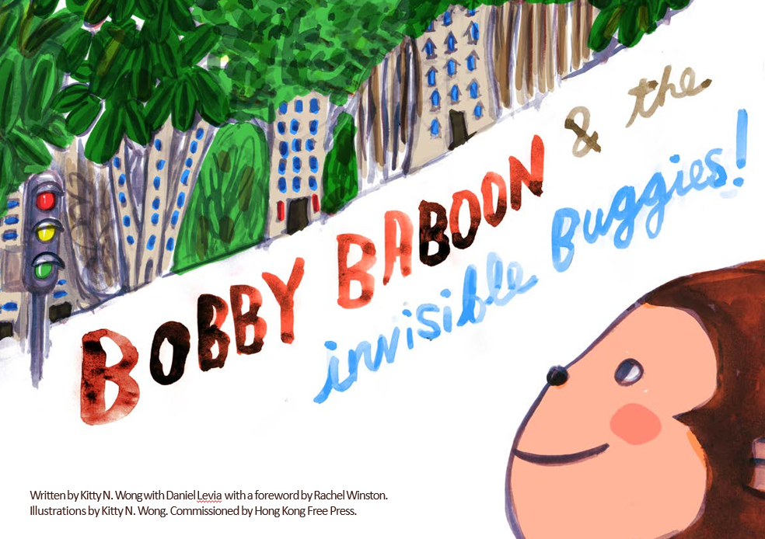

**Worksheet #1: Note for parents**

Many children’s experiences recently have been restrictive and anxiety-provoking. There have been sudden changes, changing restrictions and repeated reminders on an “invisible danger”. Naturally, children may often feel “told off” and fearful of touching things, each other and their face.

Furthermore, Children’s natural instincts to read facial expressions (for markers of whether they are safe or not) have been impeded by the widespread wearing of masks. As a result, there have been misunderstandings and a heightened sense of fear and defensiveness in children (& adults!). Read: You are not alone in noticing more arguments and hot tempers!

Understandably, underlying behavioural and emotional difficulties have been exacerbated, as the child’s lifeline of a reassuring face has been obscured.

This worksheet will help increase your child’s awareness of emotional cues that can be applied whilst wearing a mask. These skills are great to have no matter what!

As adults we can further improve communication with children by being mindful of our body language, tone of voice and perhaps even more expressive with our eyes.

*We credit* [*Science of People*](https://bit.ly/3jCmaq5) *for inspiring the first worksheet.*

**Worksheet #1: Answers:**

**Worksheet #1**

**My name is ____________________.**

Even though Bobby Baboon is wearing a mask, can you still tell how he’s feeling? Draw a line to match Bobby Baboon’s facial expression with his emotional cues.

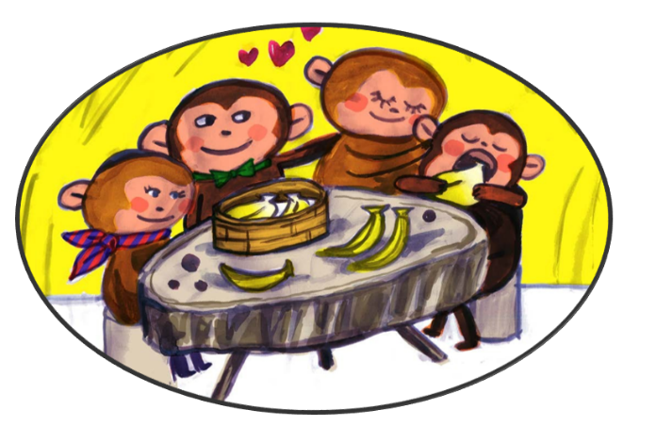

**Worksheet #2**

**My name is ____________________.**



**Worksheet #3**

**My name is ____________________.**

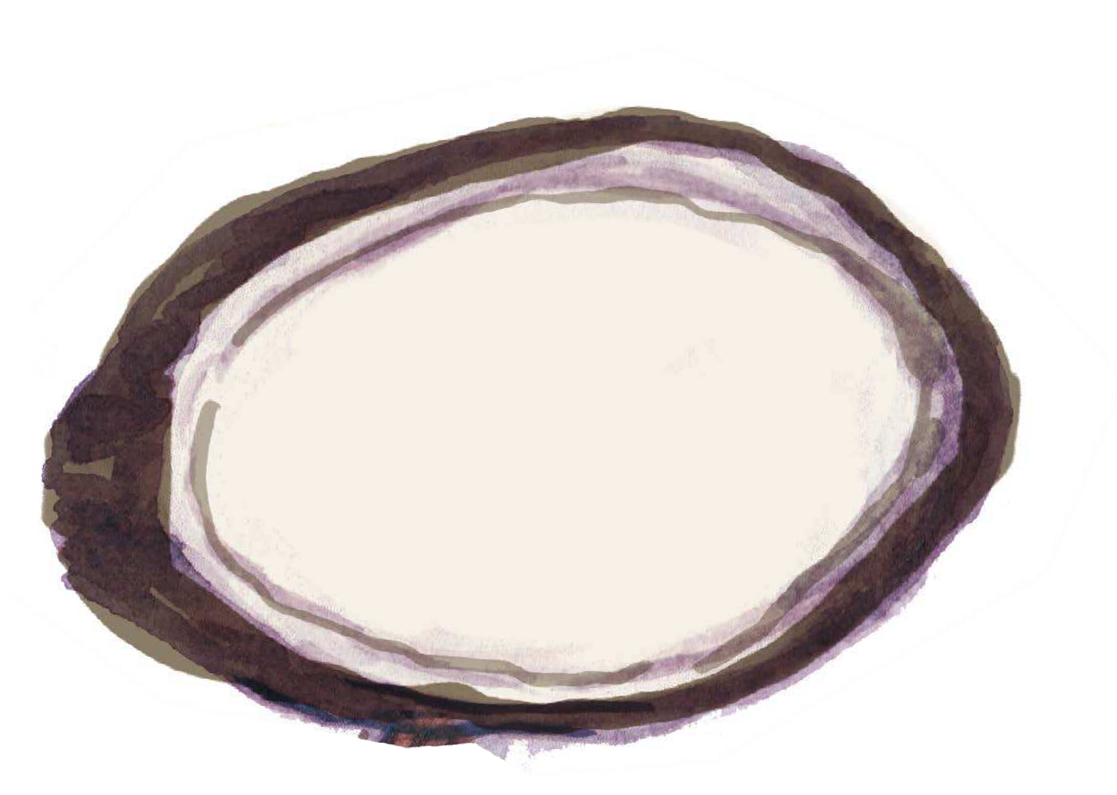In the story, Old Owl painted a picture of a hopeful future for Bobby when he was feeling low and couldn’t see that things will get better. What’s your vision of a hopeful future? Draw all the things you’re looking forward to doing in the wood carving below. And hang it up to remind yourself that, while we’ll need to stay safe now, it won’t last forever and better days are to come!